|  |  |  |
| --- | --- | --- |
| **Project Overview** | | |
| X **New activity / new funding**  **Ongoing activity / new funding**  ☐ **Ongoing activity / no-cost extension**  ☐ **Ongoing activity / other action** | **PRF #**  **Due date**  **Date submitted** | RL |

**Sponsored Programs Office**

**HAMLINE UNIVERSITY**

**Proposal Routing Form for External Grant and Contract Proposals**

**Principal Investigator** **Department** **School** **PI status (select)**

Ryan Larson CJFS CLA Faculty

$**Proposal Title:**  Advancing knowledge on the complex interplay of historical/contemporary racism, police shootings, and health

**External funding agency:** Fund for a Safer Future

**Agency Program (if applicable):** Gun Violence Prevention Research Grants

**Project start date:** 01/1/2024 **Project end date:** 12/30/2025

**Project is subcontract through:** University of Washington **Project contains a subcontract to:** Hamline University

**Total Request:**     $13,398

**Direct costs:** $12,180 **Indirect costs:** $1,218 **Cash match:** **In-Kind match:**

**Status of indirect costs:** ☐ Full recovery X Capped recovery at  10% ☐ Not allowed ☐ Waived by HU

**Brief Project Summary:**

Our proposed study is titled “The Causes and Consequences of Police Shootings”, and the goal of our mixed-method project is to advance knowledge on the complex interplay of historical/contemporary racism, police shootings, and health. We propose to:

AIM 1. Examine the impact of historical redlining and racial covenants2 on police shootings.

AIM 2. Examine the impact of police shootings on health.

AIM 3. Examine to what extent which police shootings mediate the relationship between historical redlining and racial covenants and health.

AIM 4. Understand how police shootings affect health outcomes, and how strategies of resilience used by community members may shape these processes.

Briefly, one arm of our study intends to quantify the impact of spatial exposure to historical structural racism (redlining, racial covenants) on contemporary rates of police shootings at the census-tract level. We then assess the extent to which police shootings moderate the relationship between historical racial exclusion and various health outcomes (e.g., mental health, preterm birth, community firearm injuries, etc.). We hypothesize that police firearm violence is one amongst a broader suite of mechanisms that tie historical legacies of structural racism to contemporary health disparities. We also have a qualitative arm to this study, wherein we plan to conduct semi-structured interviews with Minneapolis and St. Paul residents who have been exposed to a police shooting, and investigate the experiences and strategies of resilience amongst those who encounter police firearm violence. Our theoretical model is as follows:

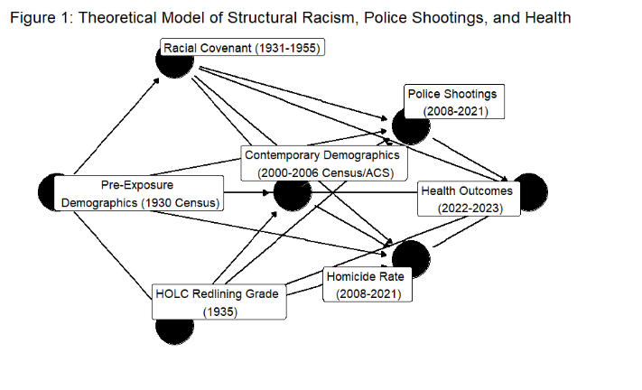

**Institutional Compliance and Project Success**

**YES NO**

☐ x 1. If funded, will Hamline University incur costs beyond the project period?

If so, attach a brief description of these projected costs.

x ☐ 2. Does this project involve the use of human subjects?

If so, status of IRB review: x To be submitted ☐ Submitted, pending approval

☐ Approved on       (date) with IRB approval number

☐ x 3. Does this project involve the use of animal subjects?

If so, status of IACUC review: ☐ To be submitted ☐ Submitted, pending approval

☐ Approved on       (date) with IACUC approval number

☐ x 4. Does this project involve the use of biohazards or radioactive materials?

If so, attach a description of the materials and your plans to ensure safe management

☐ x 5. Does this project include the use of proprietary information?

If so, attach a description of the nature of this information.

☐ x 6. Will the terms of the award limit the right of faculty or students to publish findings?

☐ x 7. Will the project require the hiring of new temporary or permanent professional staff?

x ☐ 8. Does the project involve the hiring of student assistants?

If so, how many over the course of the entire project?    1 UMN Graduate Student

☐ x 9. Does this proposal involve any course releases for Hamline faculty? If so, how many?

x ☐ 10. I have read Hamline University’s [Policy on Conflict of Interest](https://docs.google.com/document/d/14-MCVF0ljZ1ByxGyFnR1Ie5P_QubqLKGoXKsed_DKTg/edit) and certify:

x I do not have any significant financial interests to disclose with respect to the submission of this proposal

☐ I do have significant financial interests to disclose (please complete the Financial Interest Declaration Form found on the Grants, Corporate, and Foundation Relations website)

I have discussed this proposal with my department chair and forward this Proposal Routing Form, an abstract of my project, a project budget, and a budget justification for institutional review.

     

**Signature of PI** (type name) Ryan P Larson **Date** 7/17/2023

This proposal is ready for institutional review and clearance.

     

**Director, Sponsored Programs Office Date**